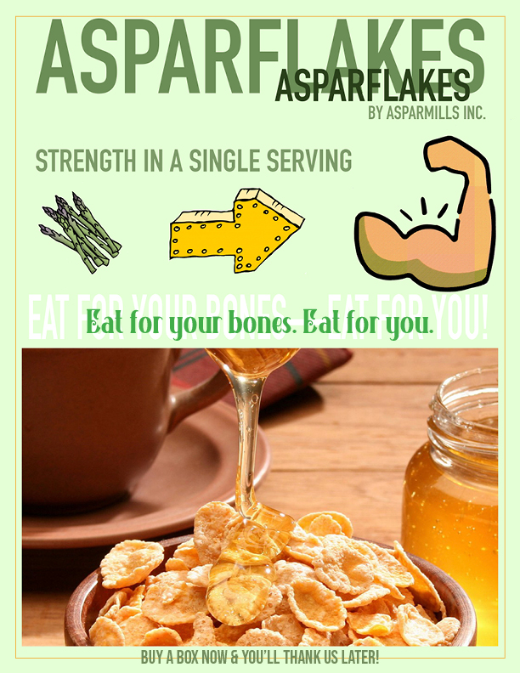
Target Audience: Demographics and Psychographics
The target audience for this ad is middle-aged (ages 45 to 65), health-conscious women in the United States and Canada. They are college-educated professionals. They are married with children. Their family income averages $90,000 per year.
These women shop in health-food stores at least twice a week. They buy healthy, organic foods for three meals a day, not just for the evening meal. Though they are not vegetarians, they prefer foods made from all-natural fruits, vegetables and grains. Because of their shopping habits, they are familiar with the traditional products from AsparPower Mills.
However, they are not familiar with AsparFlakes, a new product.
Ingredients and production processes are important to this target audience. They prefer all-natural, organic ingredients. They like old-fashioned, natural production processes.
Members of this target audience see their physicians at least once a year. Many may have been diagnosed with Osteopenia, which indicates a greater risk for Osteoporosis later in life.
We are specifically targeting women who want to fight Osteoporosis and build/maintain strong bones.
Osteoporosis, a disease in which bones become porous and brittle, is a primary health concern for this target. Post-menopausal women are the highest-risk group for osteoporosis, and our target knows that. Physicians often recommend high daily doses of calcium to prevent osteoporosis.

Product Benefits
AsparFlakes helps reduce the risk of osteopenia and osteoporosis by supplying the recommended daily allowance of calcium. Being all-natural, it is healthy and nature-friendly.

Direct Competitors and Brand Images
AsparCrunch cereal, produced by the AsparCrunch Company, holds 70 percent of the market for asparagus-flavored breakfast cereals. It is an all-natural cereal. Because it lacks tofu, however, it is not high in calcium. Our target audience views AsparCrunch only as a tasty, asparagus-flavored all-natural cereal. It sells for $6.95 for a 16 oz box.
The closest competitor to AsparCrunch is Aunt Martha's Asparagus Cereal, produced by Aunt Martha's World Conglomerate. This cereal holds approximately 20 percent of the market for asparagus-flavored breakfast cereals. Aunt Martha's is not an all-natural cereal. It includes chemical preservatives. It lacks tofu and is not high in calcium. Our target views Aunt Martha's Asparagus Cereal as a cheaper, less healthy alternative to AsparCrunch, the market leader. It sells for $4.25 for a 12 oz box.

Indirect Competitors and Brand Images
Indirect competitors include all-natural nonasparagus breakfast cereals. The best-selling all-natural nonasparagus breakfast cereal is NaturoBreakfast Solution. Our target likes it for its taste and its calcium content. However, it delivers only 50 percent of the recommended daily allowance of calcium. It sells for $5.25 for a 14 oz box.
Other indirect competitors are diets and breakfast cereals that are not all-natural. Our target usually avoids both, believing them to be unhealthy.

Product Brand Image
Current brand image: AsparPower Mills is known and respected by the target audience. However, the target has not heard of AsparFlakes all-natural breakfast cereal. The target has no brand image of AsparFlakes.
Desired brand image: Ideally, the target will view AsparFlakes as a tasty, healthy, environmentally responsible and preventative dietary supplement to help ward off osteoporosis by keeping you strong and healthy.

Brand image challenge: The target audience is not aware of our new product.
Strategic Message: The Promise
Target audience, you should buy all-natural AsparFlakes because it provides the calcium your body needs to build strong bones.

Supporting Evidence: The Proof
All-natural AsparFlakes is healthy.
AsparFlakes has 100 percent of the recommended daily allowance of calcium; it fights bone
disease.
It is made in old-fashioned brick ovens by AsparPower Mills, a name the consumer knows and trusts.
It’s a process that represents old-fashioned, wholesome values.

Basic Parts of a Print AD:
Visual: Up above
Headline: The Breakfast that makes you stronger.
Body Copy: Asparflakes are organic, all natural, and nature friendly. This cereal is baked in brick ovens with the ingredients being locally sourced from organic farms in Michigan. Asparflakes are tasty dry or with milk. Asparflakes contain 1,000 milligrams of calcium, the recommended daily allowance for adults which means when you eat Asparflakes you are cultivating stronger bones and more importantly a stronger you!
Zinger: Strength in a serving.
Call to Action: Buy a box Now and You'll thank us later.
Logo/slogans/tagline: Eat for your bones, eat for you!
Mandatories: AsparPower Mills, Inc.
Authors note:
After reading the assignment and looking at the outlines I started to brainstorm some catchy one liner for the brand Asparflakes. I created the visual in min with the target audience, which is educated married, and make 90k a year. The SMP focused more on women so I focused on them as well. These people are familiar with AsparPower Mills so I added that in the visual so they would be more comfortable with the new product. I really focused the message on strength and wanted that to be the main take away from the visual.
Final Note:
After receiving my critiques, I decided to switch my focus to fighting osteoporosis with creating/maintaining strong bones through eating Asparflakes. I also imported and modified the SMP to fit that narrative. I created a cleaner visual that gets that message across. The critiques I received were extremely helpful and helped me to better my visual and SMP and for that I am grateful.

